1. Using BASKETSIn dataset select the data as given below
a) Customer age 35 and count the customers who buy dairy and VEG products
b) Compure the GRI and Aproiri having support 22% and confidence 90% usago(prepare a sample data set in spreadsheet)

a:
SOLUTION 1a)
Expected output:
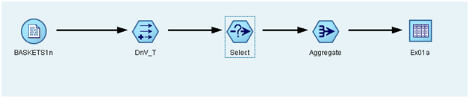

Output dataset:
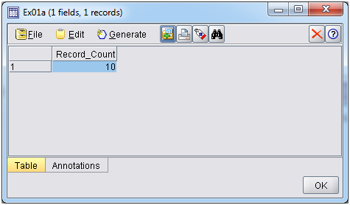
Procedure:
1. Specify the name of the file. You can enter a filename or click the ellipsis button (...) to select a file. The file path is shown once you have selected a file, and its contents are displayed with delimiters in the panel below it.
2. Select var.file from sources then goto C:\Program Files (x86)\SPSS Clementine\11.1\Demos\BASKETS1n we get the baskets in file.
3. Go to field options and select Derive flag and give condition as dairy = 'T' and cannedveg = 'T' and fruitveg = 'T' and click OK based on the conditions the truth values are shown and records are selected.
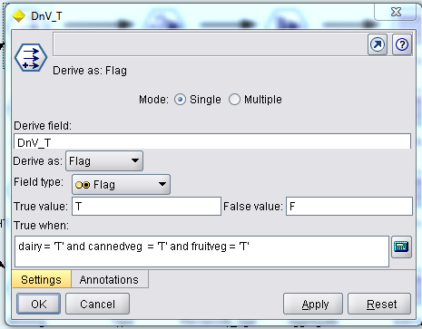
4. Goto options search for the Select give the condition as [ (age < 35) and DnV_T = 'T' ]
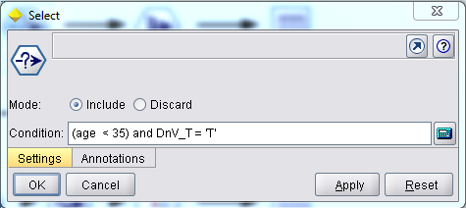
5. If both the conditions are true it counts the number of records.
6. Select the Aggregate operation to retrieve sum and max of the records.
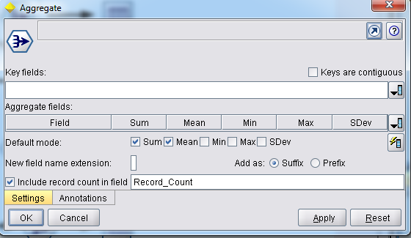
7. Select output table and connect with aggregator
8. Right click on output table and execute it.
9. Then click on run now output will be displayed.

B:

Expected output:
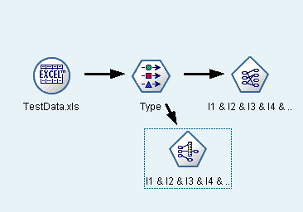

Input data set: An Excel file is prepared as shown below

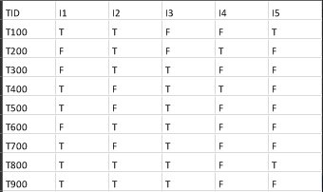

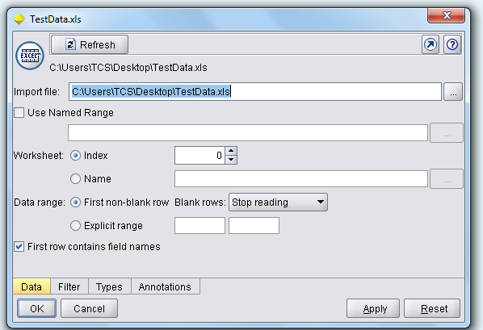

Output dataset:
The below outputs shows that there is no difference in rules generated from the Apriori and GRI ( Generalized Rule Induction ), but the order is changed. In Apriori, first low level frequent item sets rules are generated and subsequently the next level frequent itemset rules. Whereas in GRI, the rules are generated on Items i.e. first largest rule then smallest rule size for one item, then the same for subsequent items.

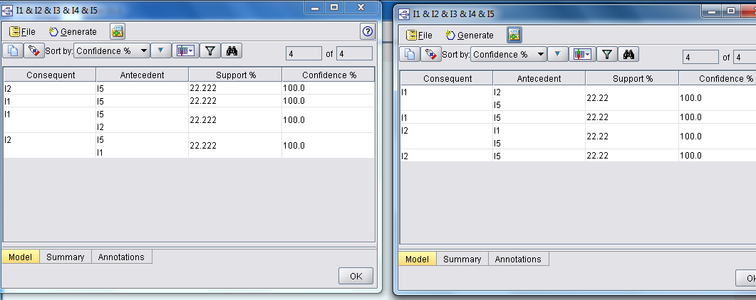

Procedure: The following are the nodes used for this exercise with respective settings.
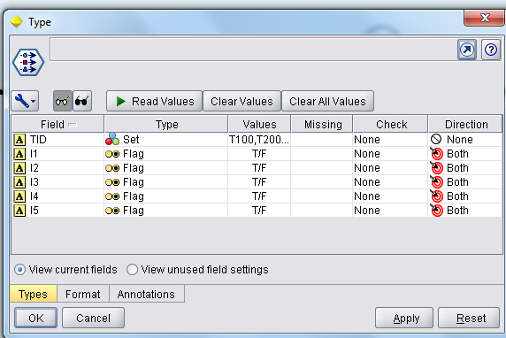
Settings for Apriori
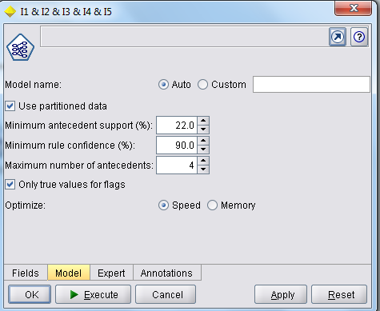

Settings for GRI
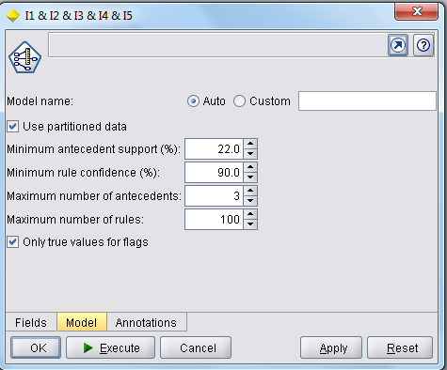

2a) Using BASKETSIn, Find the AVG income of customers who buy atleast 5 products. Derive the field whose homeown is 'YES' and Age 30 and sort data w.r.t. income in Ascending order, and output only the item fields.
b)Determine the Drugs (Drugin) importance w.rt Age, Cholesterol and BP and Compare the CS.0 and Neural Net

a:

Expected output:
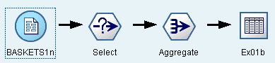

Output dataset:
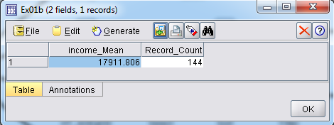
Procedure:
1. Specify the name of the file. You can enter a filename or click the ellipsis button (...) to select a file. The file path is shown once you have selected a file, and its contents are displayed with delimiters in the panel below it.
2. Select var.file from sources then goto C:\Program Files (x86)\SPSS Clementine\11.1\Demos\BASKETS1n we get the baskets in file.
3. Goto options search for the Select give the condition as as shown in figure.
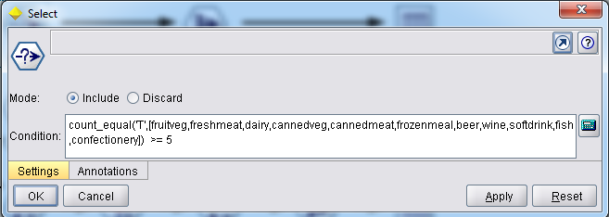
4. If the condition is true it counts the number of records.
5. Select the Aggregate operation to retrieve income_Mean and count of the records.
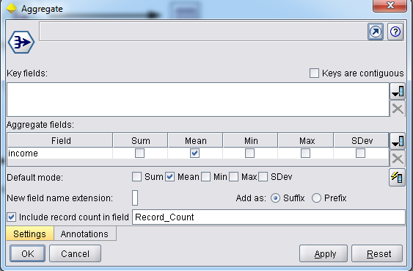
6. Select output table and connect with aggregator
7. Right click on output table and execute it.
8. Then click on run now output will be displayed.

SOLUTION 1c)
Expected output:

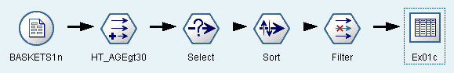
Output dataset:
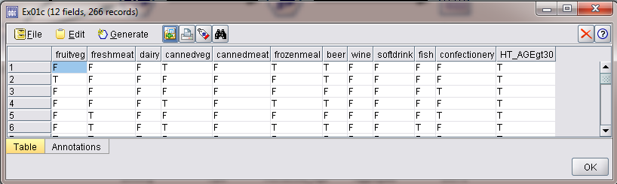

Procedure:
1. Specify the name of the file. You can enter a filename or click the ellipsis button (...) to select a file. The file path is shown once you have selected a file, and its contents are displayed with delimiters in the panel below it.
2. Select var.file from sources then goto C:\Program Files (x86)\SPSS Clementine\11.1\Demos\BASKETS1n we get the baskets in file.
3. Goto Field ops search for the Derive give the condition as as shown in figure.
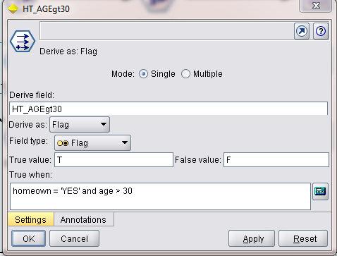
4. Connect Derive to Select with the condition shown in figure
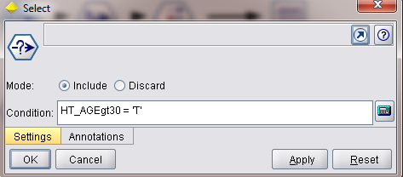

5. Connect Select to Sort for sorting Income in ascending order
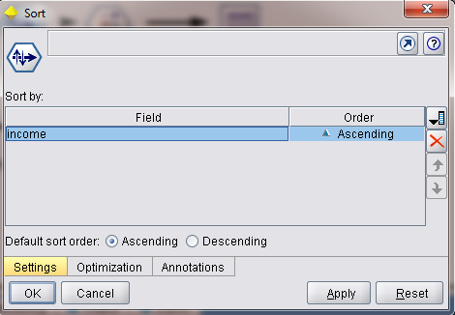
6. Connect Sort to Filter out all the non-item fields.
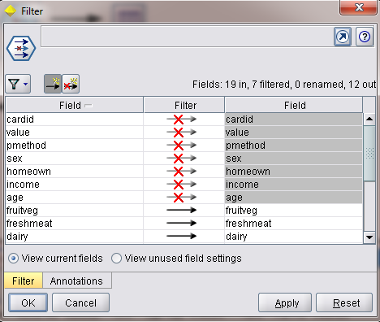
7. Select output table and connect with Filter.
7. Right click on output table and execute it.
8. Then click on run now output will be displayed.

B:

Expected output:
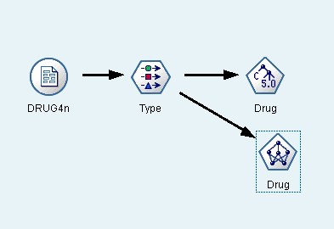
Input data set:
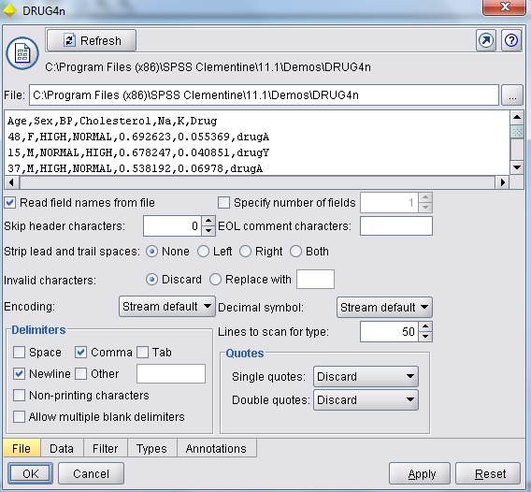

Output dataset:

Output of Neural Net Model
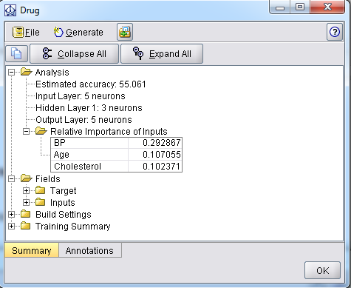

Output of C5.0 Model
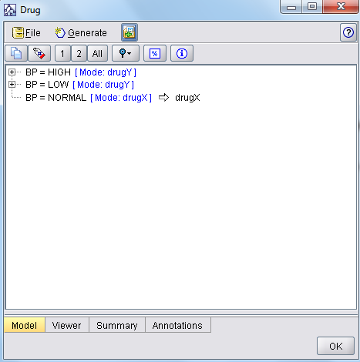
Output of C5.0 Model viewer which is shown in tree format

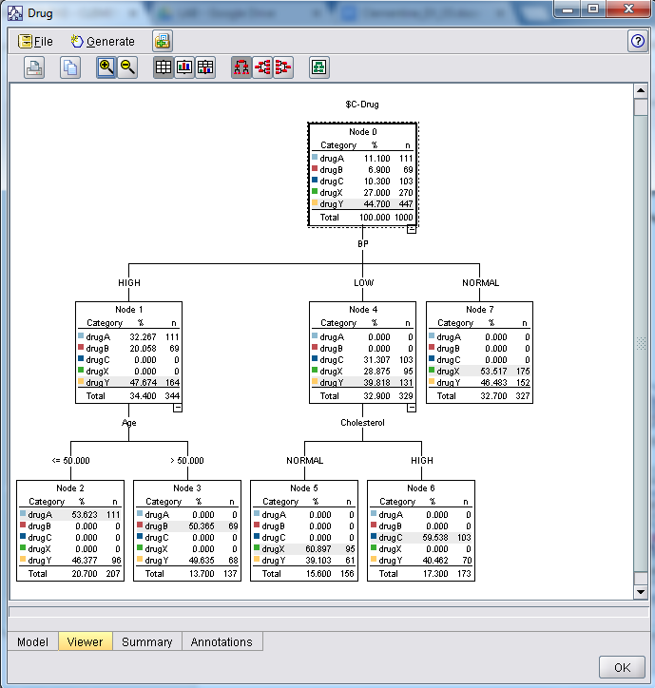

Comparision: Attribute Importance is as follows
Neural net Model : BP- 0.2928, Age- 0.1070, Cholestrol- 0.1023
C 5.0 : 2 Level Decision Tree is prepared with BP as root attribute (level 1) with Age and Cholesterol Attributes at level 2
** As a result Neural Net and C 5.0 Models are giving the same information.

Procedure: The following are the nodes used for this exercise with respective settings.

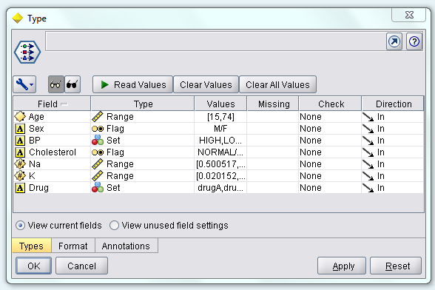
Settings for C5.0 Model
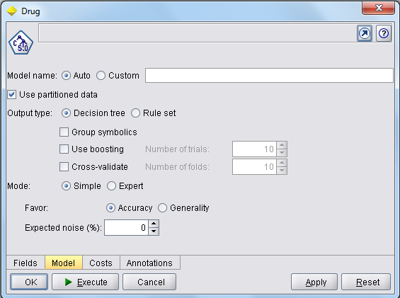

Settings for Neural Net Model

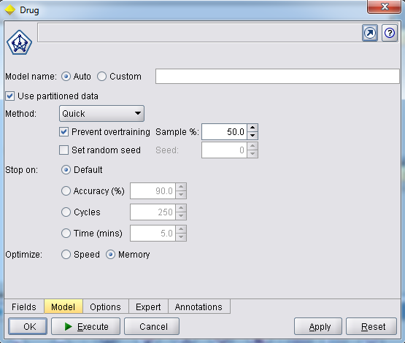

3a) Using BASKETSin. Find the mean value of salary w.r.t age-[Young, Middle, Senior)
bjUsing BASKETSIN, Find the association rules only for items using Apriori model with minimum support 3% and confidence 90%.

A:

Expected output:
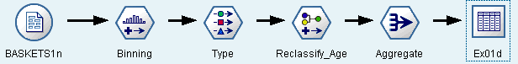
Output dataset:
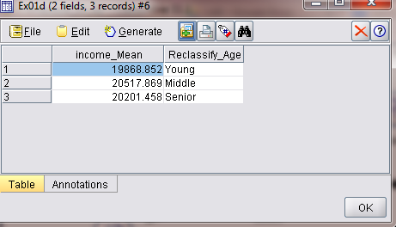
Procedure:
1. Specify the name of the file. You can enter a filename or click the ellipsis button (...) to select a file. The file path is shown once you have selected a file, and its contents are displayed with delimiters in the panel below it.
2. Select var.file from sources then goto C:\Program Files (x86)\SPSS Clementine\11.1\Demos\BASKETS1n we get the baskets in file.
3. Goto Field ops search for the Binning give the condition as as shown in figure.
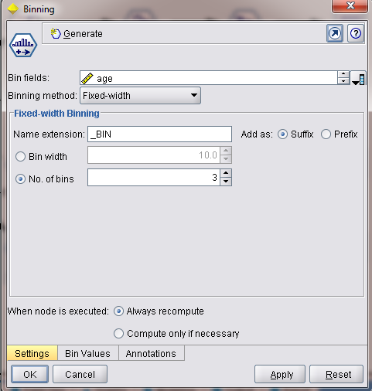

4. Connect Binning to Type to read data types and values as shown in figure
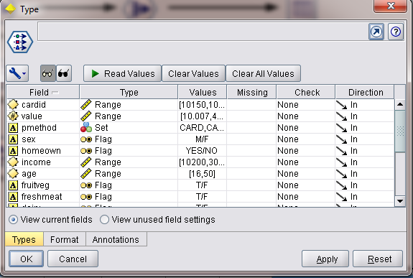

5. Connect Type to Reclassify, for classifying age binned in 1,2,3 to Young,Middle,Senior respectively.
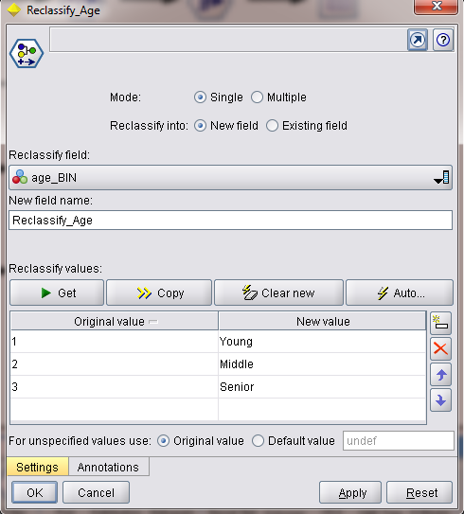

6. Connect Reclassify to Aggregate to get the income_Mean w.r.t. Different age categories.
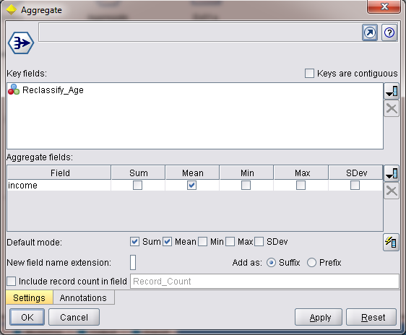

7. Select output table and connect with Aggregate.
8. Right click on output table and execute it.
9. Then click on run now output will be displayed.

B:

Expected output:
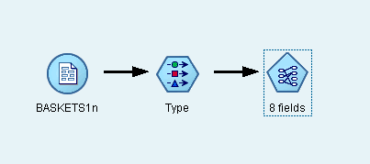

Input data set:
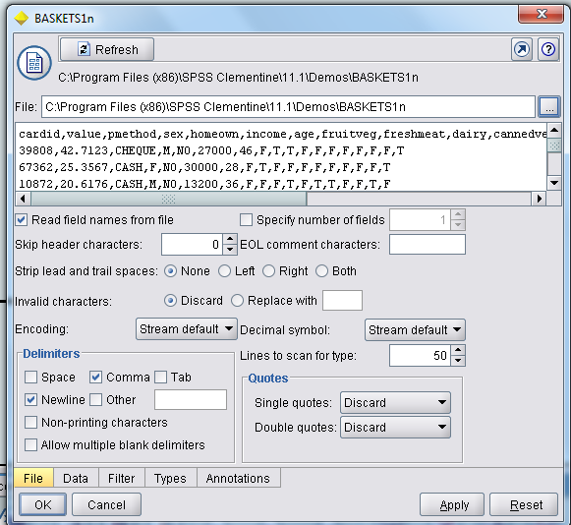

Output dataset:
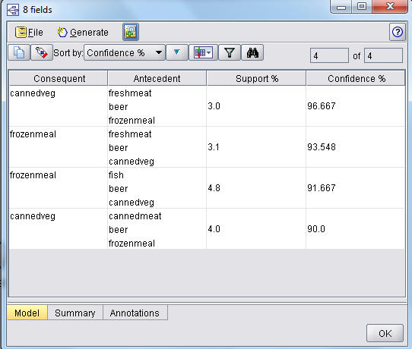

Procedure: The following are the nodes used for this exercise with respective settings.
Type : Using this node we read values and type of each attribute, the non-item attribute are given direction as none and all Item based attributes are given as both input and output to the Apriori Model.
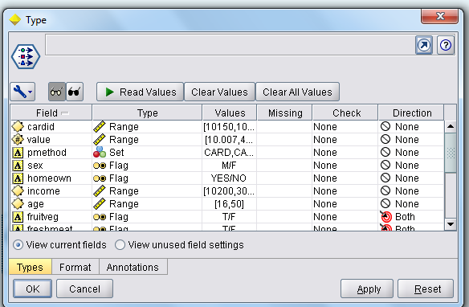
Model : The below diagram represents the settings for the Apriori Model.

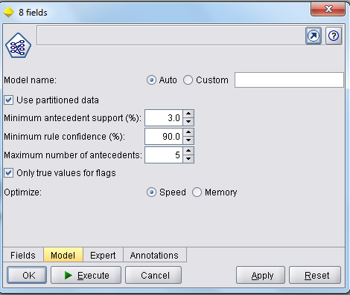

As we execute this the Apriori Model is build, one we browse the model we can see the resultant rules as output.

4. Using DRUG3n and DRUG4n datasets select the data as given below
a) Select 50% of records where maximum type of drug are present along with no restrictions on remaining drugs, and use histogram graph of age w.rt BP. Take the equal number of samples of each drug and calculate the Std. Dev. of age w.r.t drug and compare it with complete data Std.
Dev, of age w.rt drug and give a conclusion statement.
b)Determine the importance of the attributes using K-Means from Drugën and Drug4n datasets

a:

SOLUTION 2a)
Expected output:
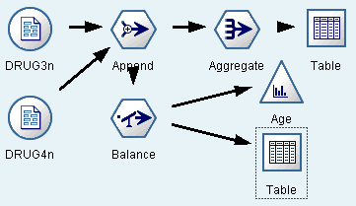
Output dataset/ graph:
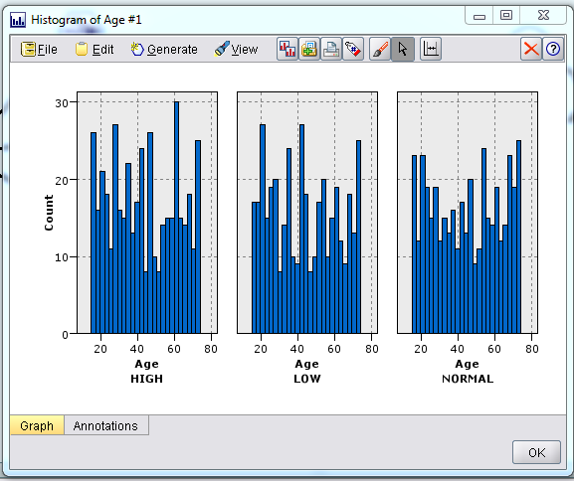

Procedure: The following are the nodes used for this exercise with respective settings.
APPEND:
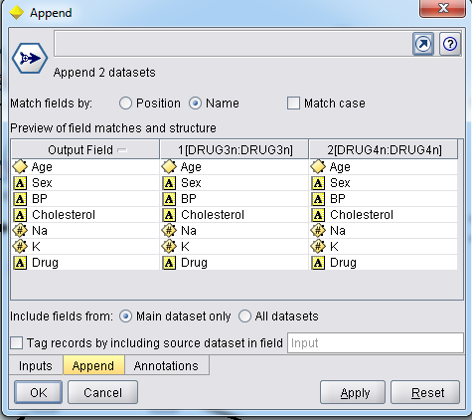
Aggregate: to get the count of all Drug types as shown in following output table.
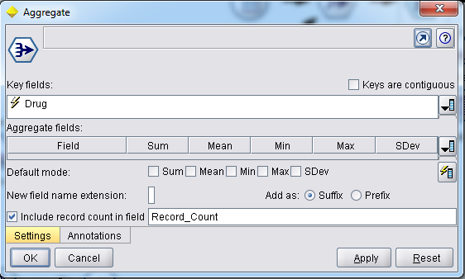

Table: from the following output we can identify that ‘drugY’ has maximum number of records when compared to remaining Drug types.

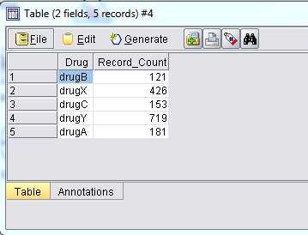

Balance: for selecting 50% of records for ‘drugY’

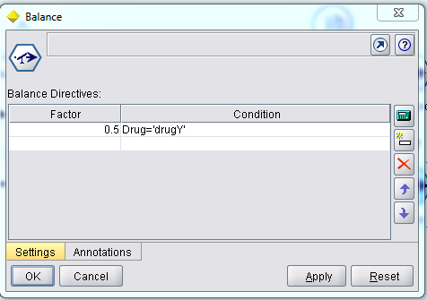

Histogram: The following Histogram node gives the output of Age w.r.t. BP
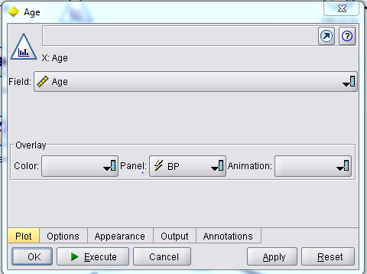
Table: It is an output of the records after selecting 50% of ‘drugY’ and no restrictions on remaining Drugs
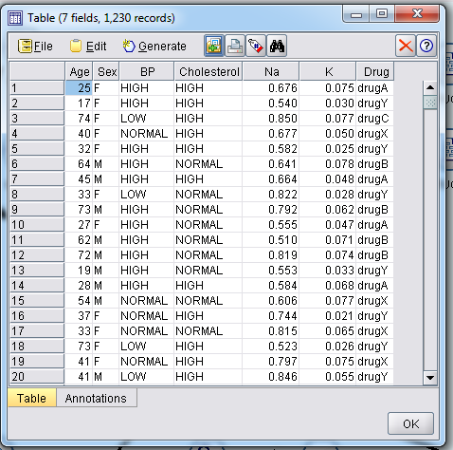

SOLUTION 2b)
Expected output:
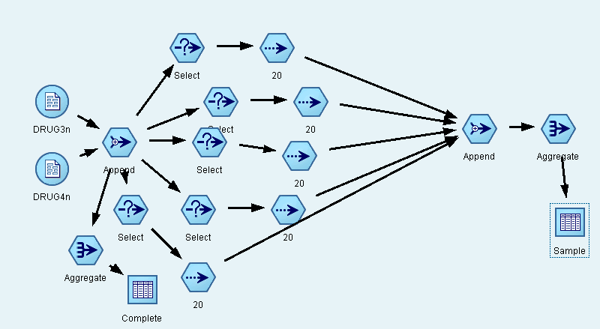

Output dataset:
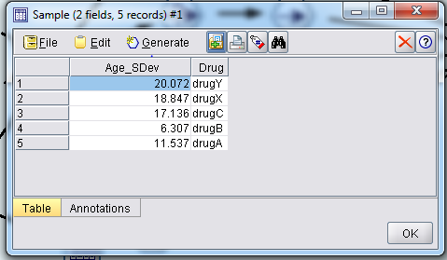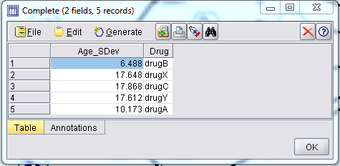

When the above Sample data output and complete data output is compared Standard Deviation of Age w.r.t Each drug type is almost similar, but there is a bit difference in Standard Deviation of Age w.r.t drugX, drugY and drugC in Sample data where as in complete data Standard Deviation of Age for the above drug types has minor difference.

Procedure: The following are the nodes used for this exercise with respective settings.

APPEND
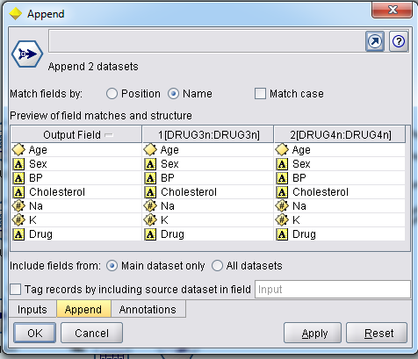

SELECT and SAMPLE: This procedure is followed for remaining drug types types where 20 equal samples of each drug type is selected
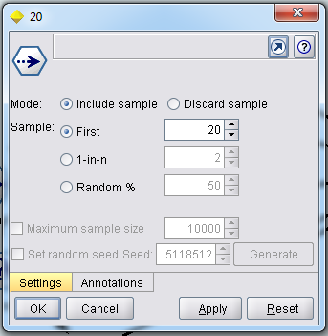
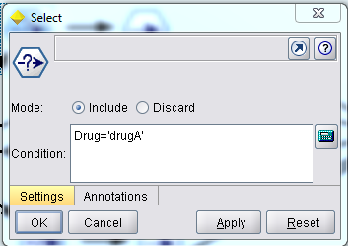

APPEND: Appending all samples
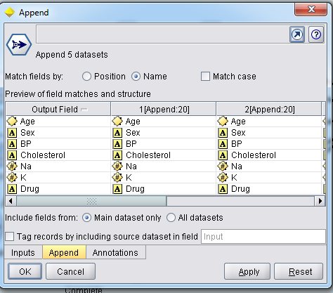

Sample Aggregate: Aggregate of Sample data

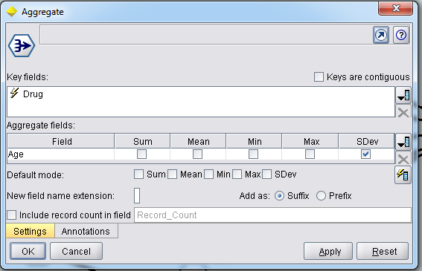
Complete Aggregate: Aggregate of Complete data

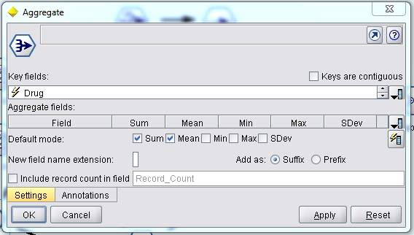

B:

SOLUTION 3d)
Expected output:
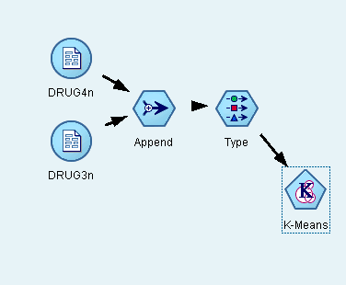

Input data set:

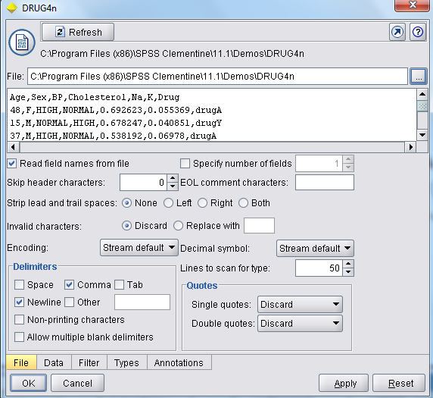

Output dataset:
The following output shows which attributes are important. (The unimportant attributes are Sex and Age)

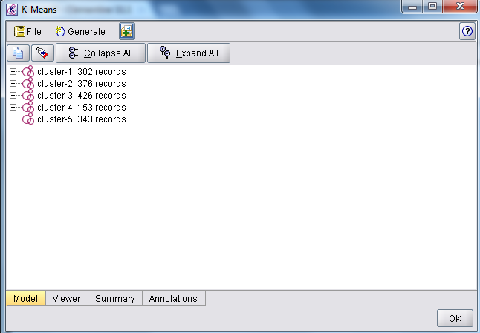
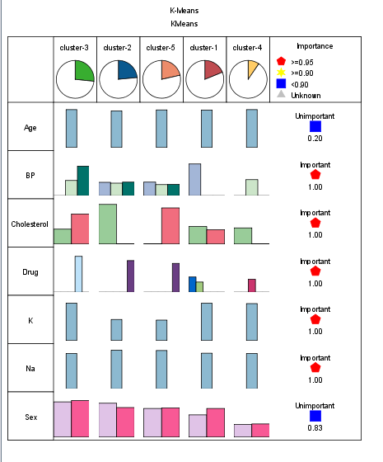

Procedure: The following are the nodes used for this exercise with respective settings.
Append
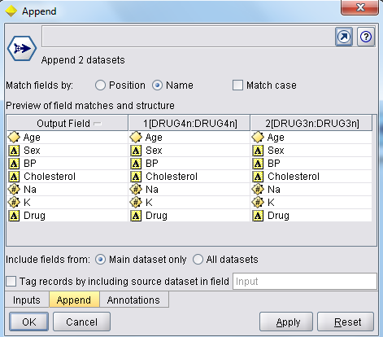
Setting for K-Means
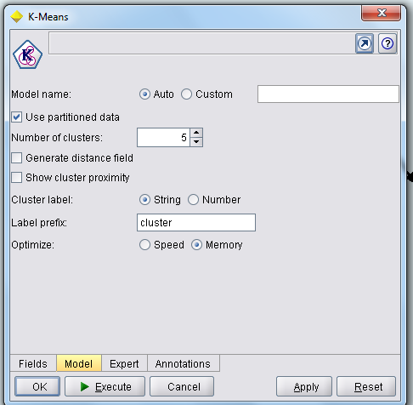

5 a) Using DRUG3n and DRUG4n datasets List 5 strong associations of attribute values, and derive and display the data.
b)Determine the Drugs(Drug4n) importance w.rt Age, Cholesterol and BP and Compare the C5.0 and Neural Net

a:

SOLUTION 2c)
Expected output:
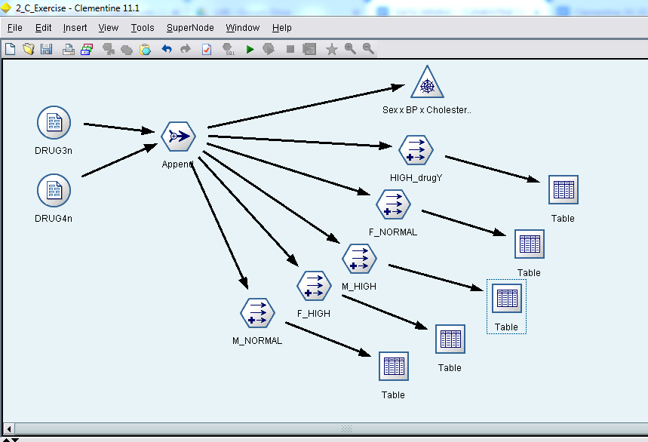
Output dataset: The following is the output for Sex = ‘M’ and Cholesterol = ‘High’
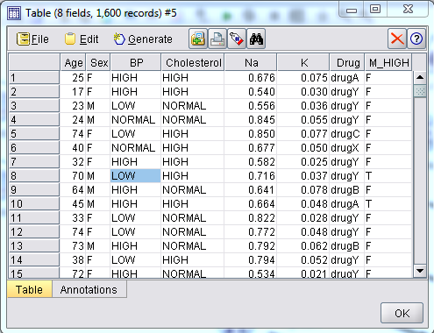
Procedure: The following are the nodes used for this exercise with respective settings.

APPEND
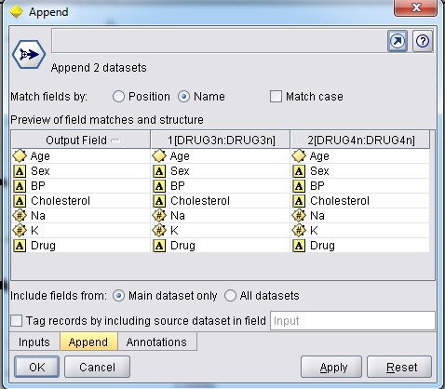
WEB: Plotting the web for Sex, BP, Cholesterol and Drug to get 5 strong associations
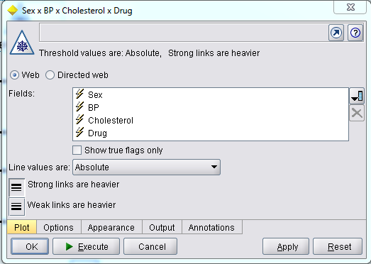
When web is created showing 5 strong links, we have to derive nodes for every links by right clicking on link and generate derive node for link.
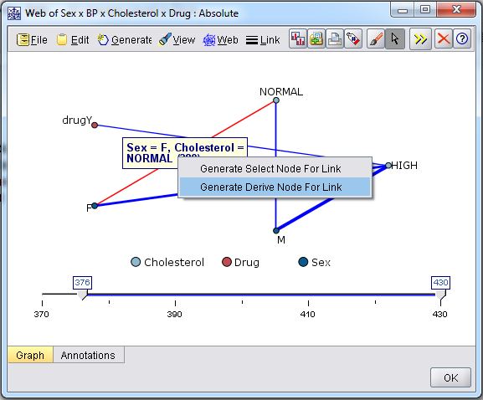

When a derive node is created from link the following is the configuration of derive node
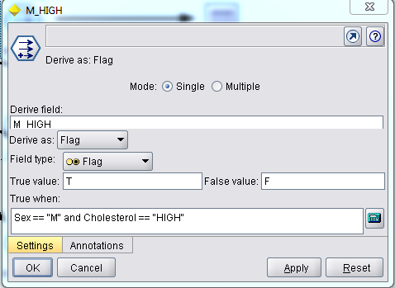

SOLUTION 2d)
Expected output:
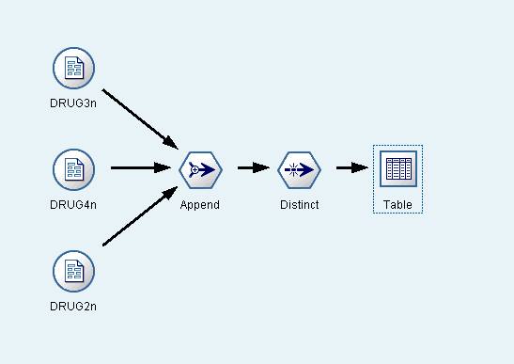
Output dataset: The following output is showing the records with distinct value of ages.

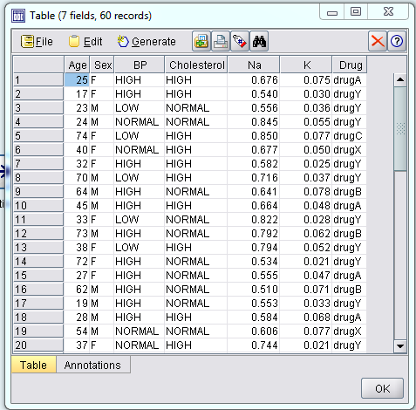
Procedure: The following are the nodes used for this exercise with respective settings.
Append:
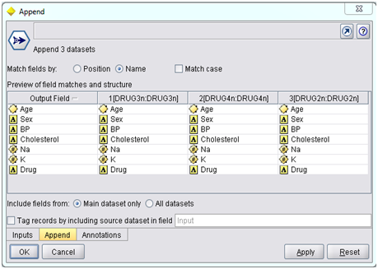
Appended data sets are given in accordance with age are exported to output graphs.

Distinct Age:

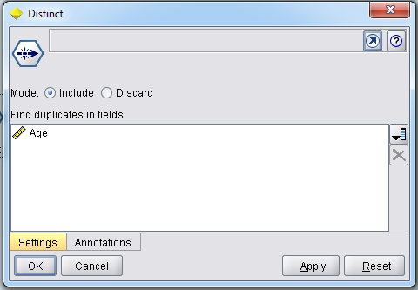

B:
Same as 2 b

6 a) Using DRUG3n and DRUG4n datasets Append DRUG2n dataset to given datasets and consider distinct values of Age. Using the above 3 datasets (DRUG2n, DRUG3n, DRUG40) perform the following
1) Young Age 30, Middle Age 30 and 50, Senior Age>50
ii) Multi plot the above Age categories with Na and K and drug
b)Determine the DrugstDrug4n) importance wirt Age, Cholesterol and BP and Compare the C5.0 and Neural Net.

A:

SOLUTION 2e)
Expected output:
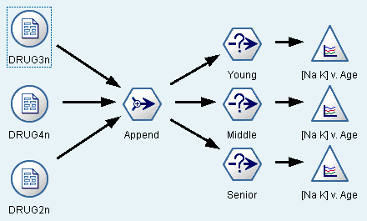
Output dataset/graph:
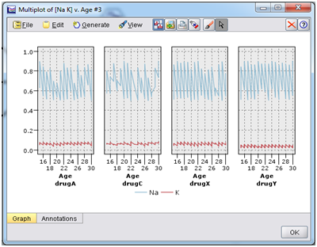
Above is Multi plot the above Young_Age categories with Na and K and drug
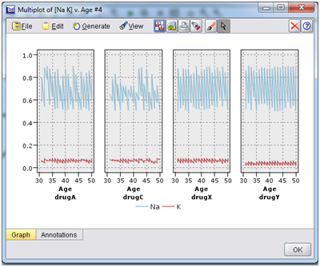
Above is Multi plot the above Middle_Age categories with Na and K and drug
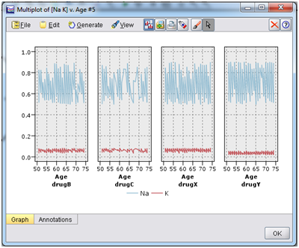
Above is Multi plot the above Senior_Age categories with Na and K and drug

Procedure: The following are the nodes used for this exercise with respective settings.

Append:


Appended data sets are given in accordance with age are exported to output graphs.

Select Age = Young:
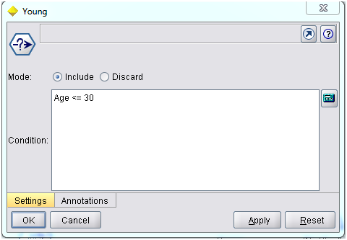

Select Age = Middle:
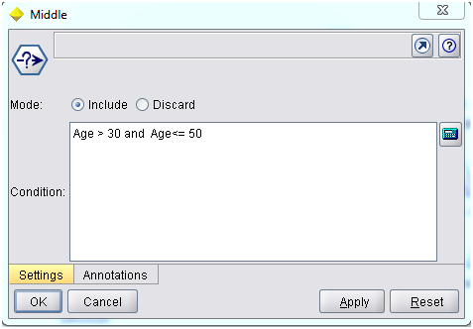
Select Age = Senior:
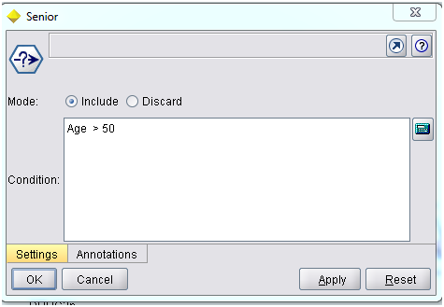
For each Select of age we use Multi Plot as shown in output.

B:

2 b

